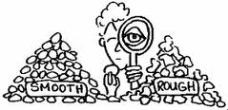
Rock/Mineral  Type | Color | Size | Shape | Texture | Smell | Weight | Streak  Color | Magnetic | Other  Observations
Student Name: ___________________________________ #:_______ Date:______________________ Created by: D.Alger

