Exploring Rocks and Minerals Online
Minerals in your Home http://www.minsocam.org/MSA/K12/uses/uses.html
Location | Item | Minerals
Sedimentary Rocks
Rock which was formed out of soil, silt, sand, seashells, bits of pieces of everything. The tiny bits settled and built up in thick layers. Minerals from water seeped into the spaces between the particles and bonded them into solid rock. The Grand Canyon is made up of sandstone, limestone, and shale which are all sedimentary rocks.
You will need:
Mixing bowl Sand Epsom salt Spoon Water
Small paper cup Pieces of shells, twigs, earth materials
Mix 1 cup of water and 1/2 cup of Epsom salt in a mixing bowl. Stir until most of the salt dissolves. Place about 1 inch of sand in a small paper cup. Add enough salt solution to just cover the sand. Mix well. Let the mixture stand until dry (about 2 to 3 days). Cut off the paper.
1. What do you predict will happen?
________________________________________________________________________________________________________________________________________________
2. How does the mixture stay together?
________________________________________________________________________________________________________________________________________________
Metamorphic:(means to "change")
Rock used to be igneous or sedimentary rock that was changed by heat or pressure or both. The Appalachian Mountains including the Blue Ridge are mainly metamorphic rock with a little igneous rock.
You will need:
Various Colors of Clay Waxed Paper Books
Wooden Blocks
1.)Make about 2 dozen pea-sized balls from clay of different colors to represent rock particles. Place the clay balls close together on a piece of waxed pager. Place a second sheet of
waxed paper on top of the clay balls.
2.)Now stack some books or wooden blocks on top of the waxed paper. Imagine that the books are layers of rock building up on top of the rock particles. The pressure of the rock particles increases as you add each book. Heat builds as the rock particles are pushed deeper into the Earth's crust.
3.)Now remove the books and peel away the waxed paper. Look at the clay. An entirely new kind of rock has been formed. The same thing happens to igneous and sedimentary rocks when they are changed.
1.) Predict what will happen as the pressure is increased.
________________________________________________________________________________________________
2.) Describe your metamorphic rock. How does it compare to those found in the earth?
Exploring Rocks and Minerals Online
Discover Various Types of Rocks (includes pictures and a brief summary) http://www.sciencenetlinks.com/ebook/rocks2/rock_index.html
Mineral | Appearance | Uses
Using Reference Books to Locate Information
1.) Name 3 minerals that have a similar COLOR.
___________ ____________ ___________

2.) Name 3 minerals that have a similar TEXTURE.
__________ ____________ ___________

3.) Name 3 METAMORPHIC rocks.
__________ ___________ ___________

4.) Name 3 SEDIMENTARY rocks.
__________ ___________ ___________

5.) Name 3 IGNEOUS rocks.
__________ ___________ ___________

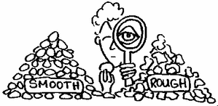
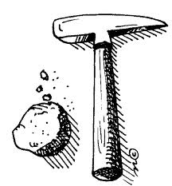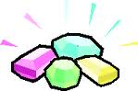
Name:_________________________
Date:__________________________
Created By: D.Alger
Science Vocabulary and Key Terms
1. What is a rock?
________________________________________________________________________________
2. What is a mineral?
________________________________________________________________________________
3. What is an ore?
________________________________________________________________________________
4. Name at least 3 tools that help test hardness.
________________________________________________________________________________________________________________________
5. Name the physical properties that describe rocks.
________________________________________________________________________________________________________________________

6. Create a new mineral. Describe its physical properties. Describe what it is used for.
Name of New Mineral:_______________________
Physical Properties: ________________________________________________________________________________________________________________________________________________________________________________________________________________________________________________________________________________________________________________________________
Uses:
________________________________________________________________________________________________________________________________________________________________________________________________________________________________________________________________________________________

