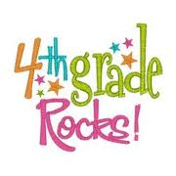
Student Supply List
- 7 Composition Notebooks (No Spirals) & 5 folders with prongs for each of the following:
  - Reading (yellow notebook & yellow folder)
  - Writing (black notebook & black folder)
  - Math (red notebook & red folder)
  - Science (green notebook & green folder)
  - Social Studies (blue notebook & blue folder)
  - Journal (your choice of color/design) Room9 ONLY
  - Reading log(your choice of color/design)Room9ONLY

- No. 2 Pencils
- Highlighter
- Erasers
- Pencil Box or Pouch
- Crayons (no larger than 24 pack)
- Colored Pencils
- Washable Markers
- Student Scissors
- Glue Sticks (We use these daily in our interactive notebooks.)
- Small Pencil Sharpener (not electric)
- Earbuds (if possible)

*********BE SURE TO HAVE EXTRAS FOR WHEN YOU’RE RUNNING LOW.***********

